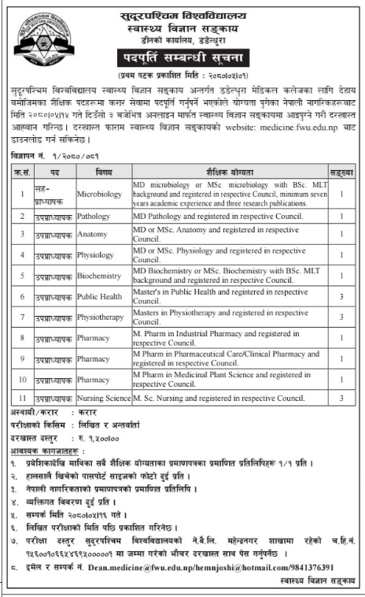

cfj]bg btf{ g+= cfj]bg kmf/fd g+=
ldlt M
;'b"/klZrdf~rn ljZjljBfno
स्वास्थ्य विज्ञान ;+sfo
-z}lIfs kbsf] s/f/ k|ltof]lutfsf] cfj]bg kmf/fd_
b/vf:t b:t'/ M
a}+s ef}r/ g+= M
ldlt M
cfj]lbt kb M ljifo M

!= cfj]bssf] gfd, y/ M g]kfnLdf M
b'j} sfg b]lvg] xfn;fn} lvr]sf] kf;kf]6{ ;fO{h kmf]6f]
-kmf]6f] / kmf/ddf kg{] u/L b:tvt ug{'kg{]_
c+u|]hLdf M
@= JolQmut ljj/0f M
-s_ gful/stf g+= lhNNff M
-v_ gful/stf k|df0fkq hf/L ldlt M
-u_ hGd ldlt M lj=;+= O{=;+=
-3_ xfnsf] pd]/ M
-ª_ lnË M prfO{ M
-r_ ljz]if lrGx -x'lnof_ M
-5_ ljjflxt eP klt jf kTgLsf] gfd M
-h_ jfh]sf] k"/f gfd ,y/, jtg M
-em_ lktfsf] k"/f gfd, y/, jtg M dftfsf] gfd, y/ M
-`_ :yfoL 7]ufgf M -gful/stf k|df0fkqdf pNn]v eP cg';f/ _ M
c~rn M lhNnf M
ufp+÷ gu/kflnsf M j8f g+= M
3/ g+= M 6]lnkmf]g÷df]jfO{n g+= M
O{d]n 7]ufgf M
-6_ c:yfoL 7]ufgf M
c~rn M lhNnf M
ufp+÷ gu/kflnsf M j8f g+= M
3/ g+= M 6]lnkmf]g÷df]jfO{n g+= M
O{d]n 7]ufgf M
#= s'g} k]zfdf sfo{/t eP M
-s_ sfo{/t kb M
-v_ :yfoL÷c:yfoL÷s/f/ M
-u_ sfof{no M

$= z}lIfs of]Uotf M - cfj]bg lbg] clGtd ldlt leq pQL0f{ u/]sf] k/LIffx?sf] ljj/0f eg]{ _

pQL0f{ u/]sf] k/LIff | pQL0f{ jif{ | cWoog lzIf0f ;+:yfsf] gfd÷ 7]ufgf | s"n k"0ff{Í | s"n k|fKtfÍ | pQL0f{ >]0fL | k|fKt k|ltzt | k|ltlnlksf] qmd gDa/
k|j]lzsf
k|lj0ftf k|df0f kq jf ;f] ;/x
:gfts jf ;f] ;/x
:gftsf]Q/ jf ;f] ;/x
Pd=kmLn
ljBfjf/Llw

%= cg'ejsf] ljj/0f M - cfj]bg lbg] clGtd ldlt leqsf] lzIf0f cg'ej pNn]v ug]{ _

SofDk;÷sfof{nosf] gfd 7]ufgf | sfo{/t kb | :yfoL÷c:yfoL s/f/ | sfdsf] ljj/0f | Afxfn u/]sf] ldlt | 5f8]sf] ldlt | hDdf cg'ej | k|ltlnlksf] qmd gDa/

k|dfl0ft ug]{ lgsfo÷sfo{no k|d'vsf] b:tvt =================================
gfd M
kb M
ldlt M
sfof{no M
-sfof{nosf] 5fk_
cfj]bssf] x:tfIf/=============================


;'b"/klZrdljZjljBfno
फोटो
स्वास्थ्य विज्ञान ;+sfo
8Lgsf] sfof{no
k|j]z–kq
!= pDd]bjf/n] eg]{ M
-s_ gfd,y/ M lj1fgkg g+=M
-v_ cfj]lbt kb M ;]jf ;d"x M
-u_ pDd]bjf/sf] b:tvt M
@= 8Lg sfof{nosf] ;DalGwtsd{rf/Ln] eg]{ M
/f]n g++= M
o; 8Lg sfof{noaf6 lnOg] plNnlvtkbsf] lnlvt k/LIffdf ;lDdlntx'gcg'dltlbO{Psf] 5 .
;'b"/klZrdljZjljBfno स्वास्थ्य विज्ञान ;+sfo 8Lg sfof{nosf] 5fk M

